I created my first new branch for Joe_smoe and named it working
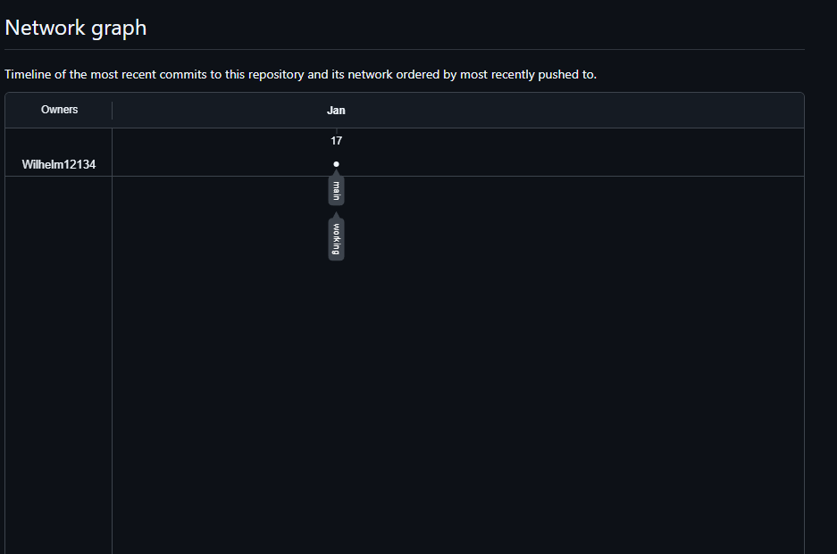
Next I cloned my directory to my local machine.
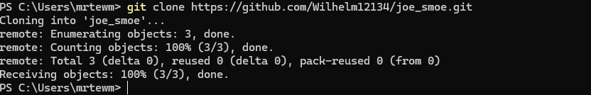
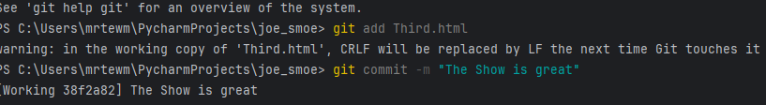
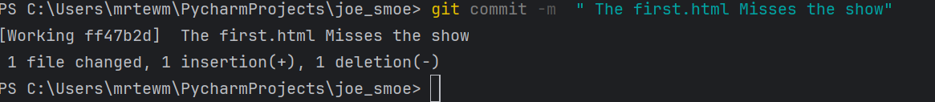
I made and committed 3 changes for the files first.html Second.html and Third.html.

I created another branch and named it test I added my school login in the README.md file. Then I pushed the changes.
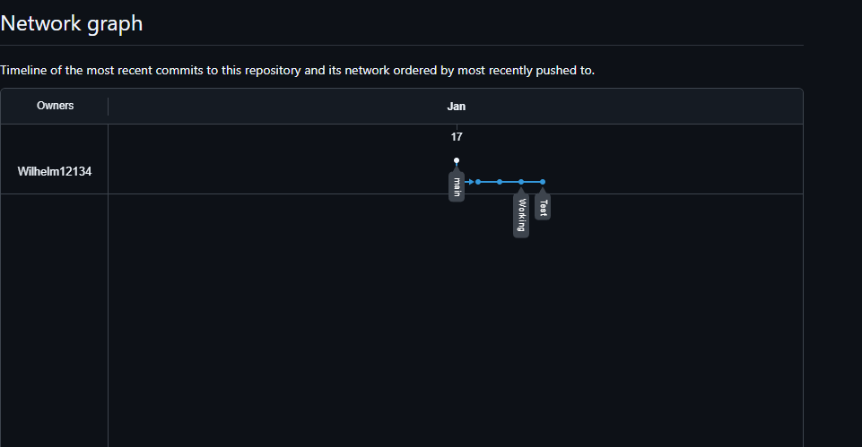
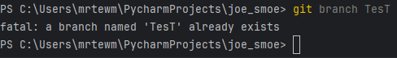
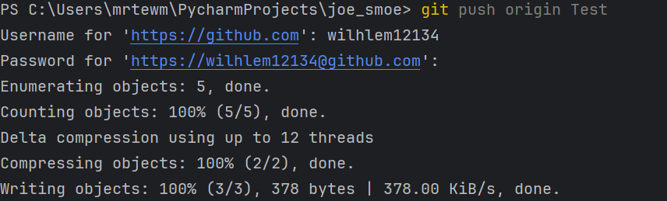

I then introduce a merge conflict and resolve it by keeping the most relevant parts. Then I merge and push changes. 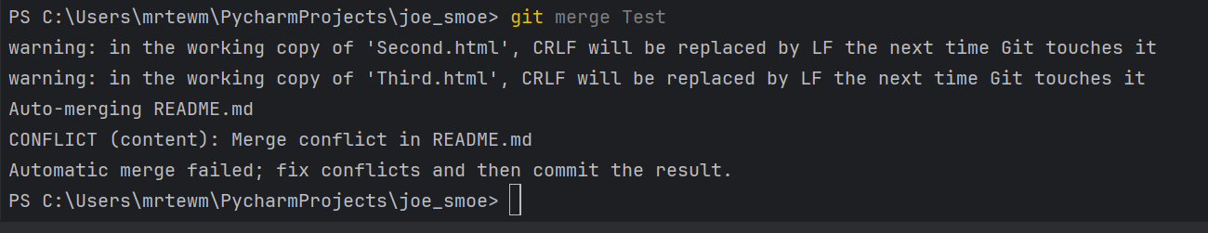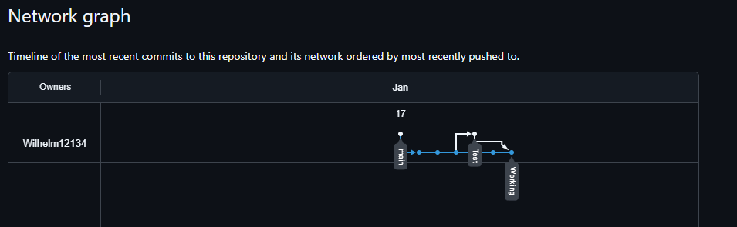

I then specify a tag for the working branch and push it to Gitlab.
